9. Plot of Contoured Diagrams of Orientation Data

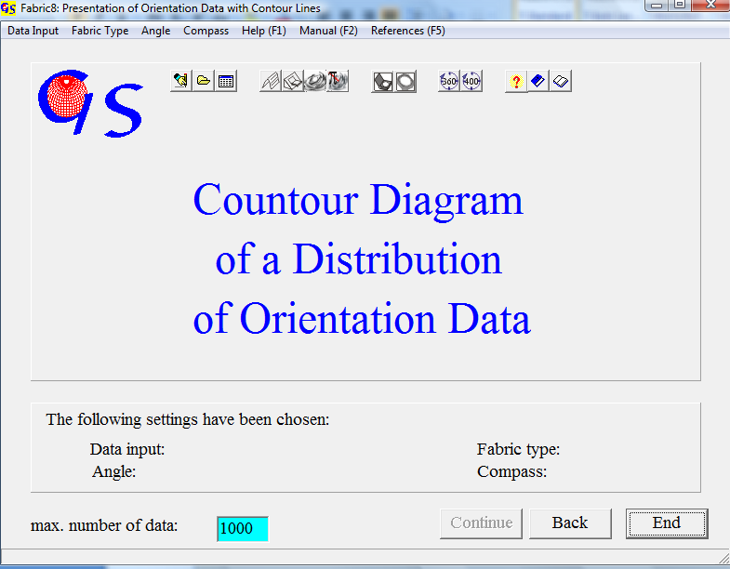
Fig. 1

This program (Fig. 1) plots contoured projections of orientation data. The starting form and data input are the same as in Programs 3, 4, and 8. The distance between the contours can either be automatically calculated in multiples of even distribution in logarithmic steps, or it can be user defined. In the first case five contour levels are calculated. The steps are logarithmically arranged from 1 % to the maximum of density. The counting calotte is fitted to the number of data. In the second case, The steps of five contour levels are put in manually. In this case the size of the counting calotte must be chosen.

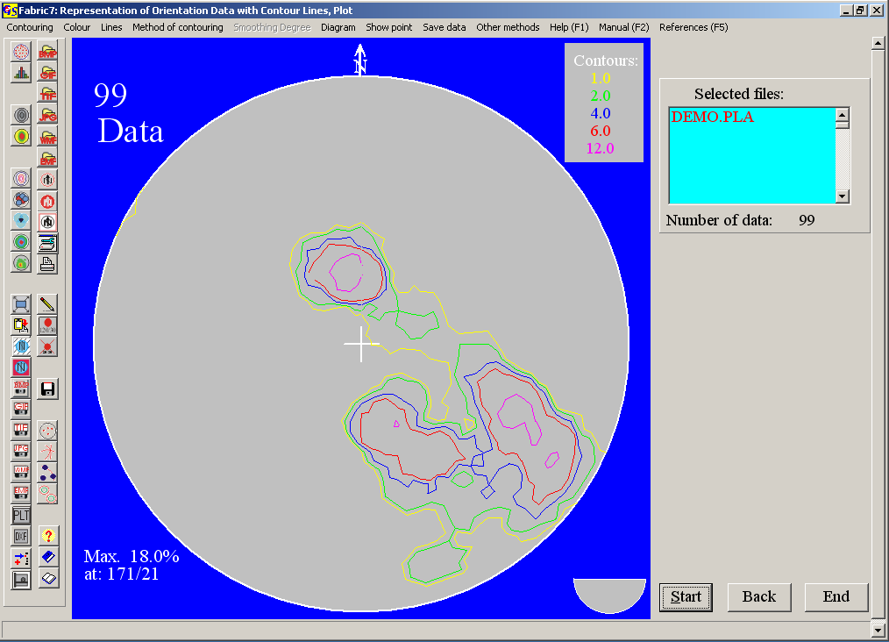
Fig. 2

Fig 2 shows the evaluation of the data used for program 3 in logarithmic steps as multiples of even distribution.. The calculated contour lines are listed in the upper left corner. The calculated maximum appears in the lower right corner. The type of contour intervals is saved in “Fabric.ini” and can be changed in the menu “Contouring” or with the speed buttons (Fig. 3).

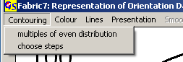
Fig. 3

Fig. 4 shows contour lines for the same data set with manual selection of contour levels and a counting calotte of 1%.
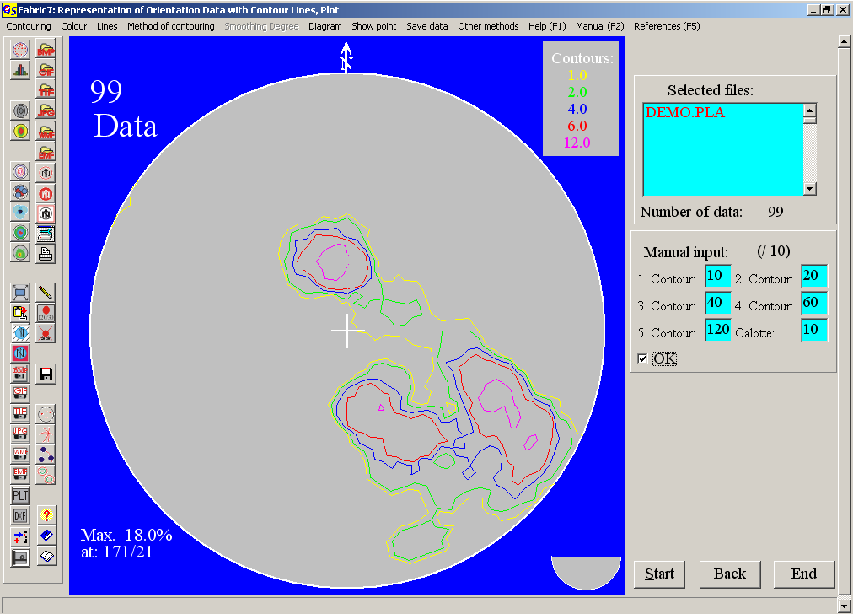
Fig. 4

With “Diagram/Plot with the printer” a vector graphic is printed. if you click these options, a panel appears on the right side (Fig. 5), in which the saved values for coordinates and radius are shown. You can change these values.
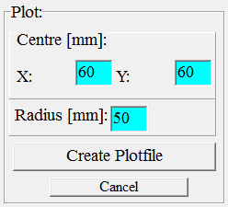
Fig. 5

In the menu "Methods of contouring" (Fig. 6) the option "Calotte/ Vectorgraphics" creates a contour line plot in vector graphics (Fig. 2, 4). The option "Calotte / Pixel graphics (in steps)" produces a diagram using the method of Mellis (1942).
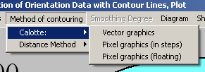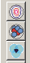
Fig. 6

Fig. 7 shows shows a diagram in pixel graphics with fixed steps between the density fields.

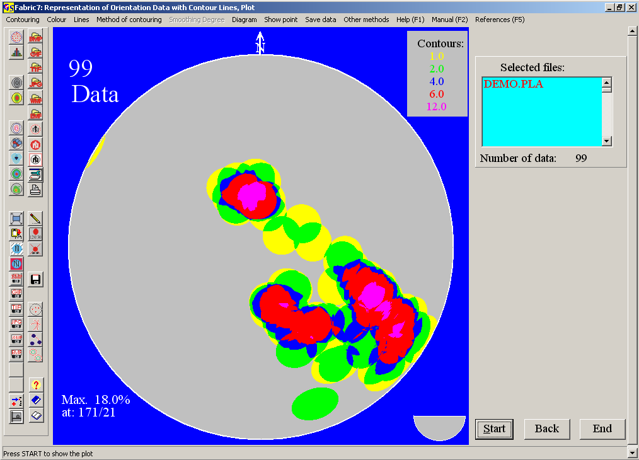
Fig. 7

Fig.8 is drawn with the same method, but the densities are shown with floating boundaries. The colours are chosen from a spectrum of HLS colours. The whole spectrum of these colours is shown in Fig. 9. By clicking on the colours for the highest and lowest contour line you choose the colours to be used in the diagram. The diagram in Fig. 8 is drawn with the colours in the white frame (blue to red, Fig. 9).

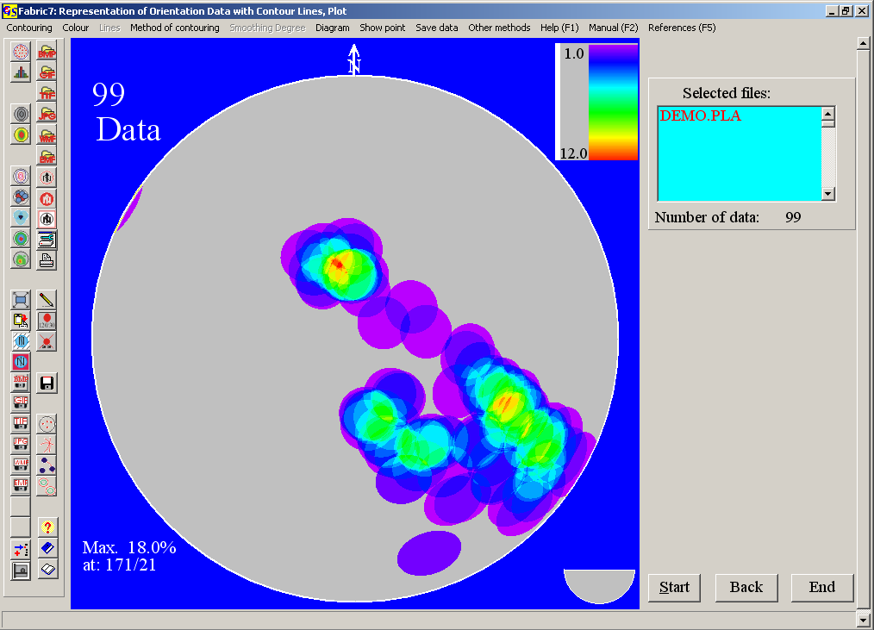
Fig. 8

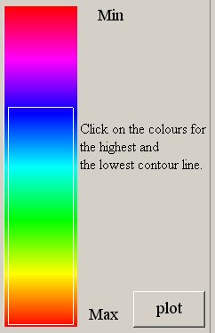 Fig 9

Distance Methods (Scaler product methods):
These methods use each pixel of the projection area as counting point. The angle between the pixel and each data point is calculated. The sum of the cosines of these angles is calculated and compared with the value for even distribution (Adam, 1989). These values are arranged in contour intervals with different colours (Fig. 10). This method produces very smooth contours.

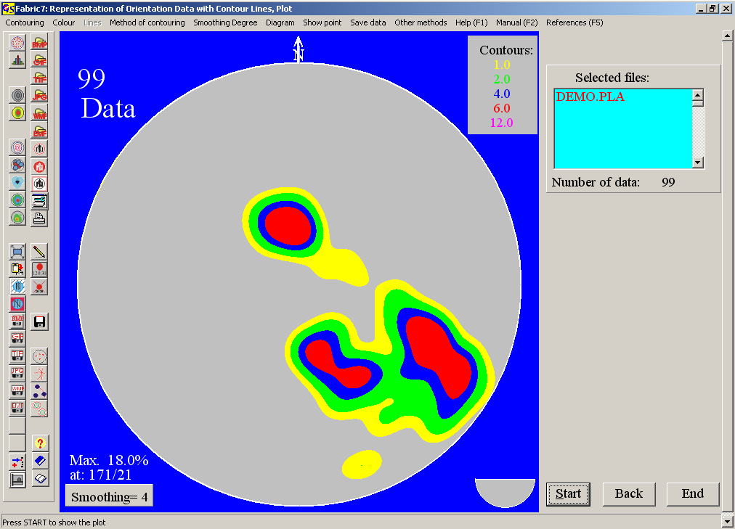Fig. 10

The smoothing factor is chosen from a scale from 1 (many details) to 10 (no details).

You can also choose floating contours with floating colours from the HLS-spectrum (Fig. 9). By clicking on the colours for the highest and lowest contour line you choose the colours to be used in the Diagram. The diagram in Fig. 11 is drawn with the colours in the white frame of Fig. 9..
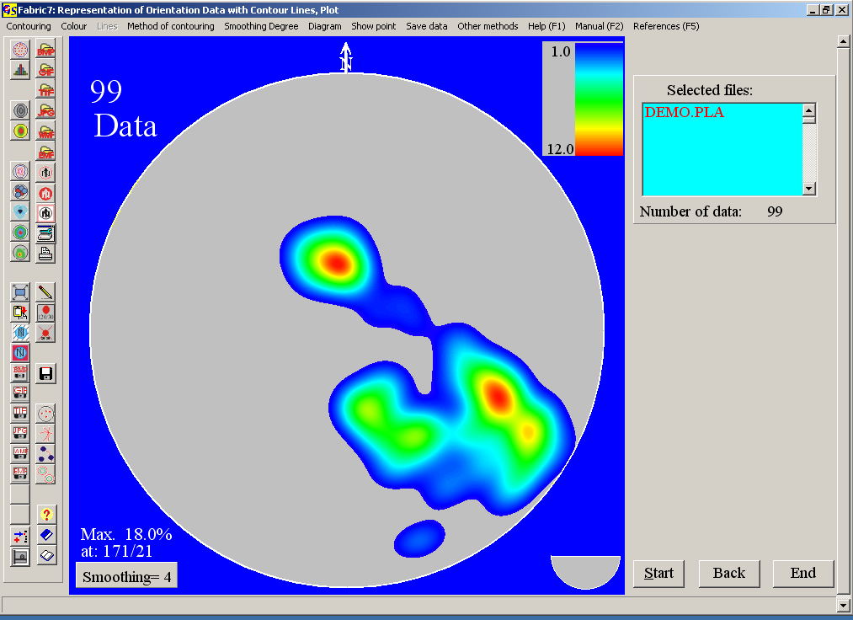
Fig. 11

Pixel-graphics cannot be used in the plot program, but they can be saved on the clipboard. With the option “Print” you can produce a hardcopy from the graphic.

With the menu "Show points" (Fig. 12) you can click on a point in the diagram
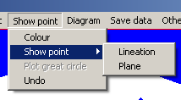
Fig. 12

then the azimuth and angle of dip of this point is indicated (Fig.13). With "colour" you can choose the colour of the point and the script.
With clicking on “Lineation“ or “Plane“ the point is interpreted as a projection of a lineation or a plane. The measures of the point are shown in the chosen
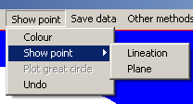
Fig. 13

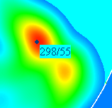
Fig. 14

colour (Fig. 14). The option “Great circle” plots a great circle to the clicked point. For the option “Lineation“ the point is interpreted as pole to a plane and for the option “Plane” as dip lineation.
When “Show point/Lineation or Plane“ is chosen the measures of the point under the mouse cursor are shown in a window on the right side of the diagram. This window is closed with the right mouse button. With “Undo” all measures are erased.
Fig. 15 shows the construction of the fold limbs and of the π−circle of a fold with this method.

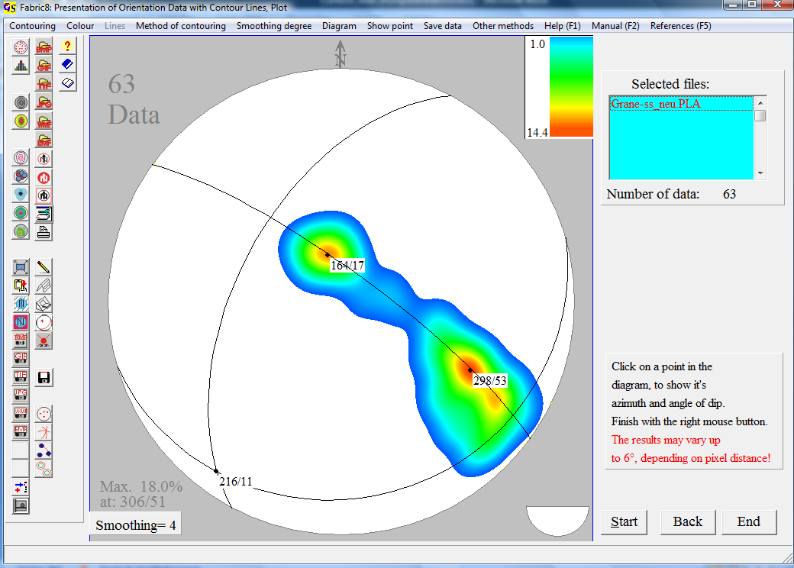
Fig. 16

With the menu "Evaluation" you can jump to the other programs which use orientation data.

Menus, not mentioned here, are described in program 3.

